

JAVA PROJECT REPORT ON
Student Attendance Monitoring and
Eligibility Verification System

Submitted by
AMALI PRABHA S
25BCS103

Under the Guidance of
Mr.ARAVIND
Technical Trainer
Technical Department, KG College of Arts and Science

Academic Year: 2025 – 2026
APRIL 2026
Semester: II

DECLARATION
I hereby declare that the project entitled “Student Attendance Monitoring and Eligibility Verification System” submitted in partial fulfillment of the requirements for the course JAVA PROGRAMMING is a record of my original work carried out under the guidance of MR.ARAVIND, Technical Trainer, Technical Department, KG College of Arts and Science.
I further declare that this project has not been submitted previously, either in part or in full, for the award of any degree, diploma, or other similar title, at this or any other institution.
I have acknowledged all sources of information used in this project wherever applicable.

April 2026
Coimbatore

________________________
Amali Prabha S

CERTIFICATE
This is to certify that the project entitled “Student Attendance Monitoring and Eligibility Verification System” is a bona fide work carried out by Amali Prabha S, I-”B” Class, 2025-2028 Batch, Department Of Computer Science, KG College of Arts & Science, in partial fulfillment of the requirements for the course Java Programming Language.
This project has been completed under my supervision and guidance during the academic period April 2026.

Place: Coimbatore
Date: 10/04/2026

Submitted for the Viva-Voce Examination held on 10/04/2026.

Guide: Head of the Department
(Technical Trainer, KGCAS) (Technical Head, KGCAS)
Mr.Aravind Dr.Boopalan Sundaramoorthy

TABLE OF CONTENTS
S. No. | Topics | Page. No.
1 | Introduction | 6
1.1 | Objective | 6
1.2 | Overview | 6
1.3 | Features | 7
2 | Program Analysis | 8
2.1 | Problem Definition | 8
2.2 | Project Overview | 8
2.3 | Scopes and Limitations | 8
3 | System Design | 10
3.1 | Modules | 10
4 | Methodology | 11
4.1 | Problem Analysis | 11
4.2 | System Design | 11
4.3 | Program Development | 12
4.4 | Testing and Validation | 12
4.5 | Result and Documentation | 12
4.6 | Algorithm | 13
4.7 | Flowchart | 13
5 | Source Code | 15
6 | Input and Output Screens | 19
7 | Discussion and Conclusion | 20
7.1 | Discussion | 20
7.2 | Conclusion | 20
8 | References | 21

ABSTRACT

The Student Attendance Monitoring and Eligibility Verification System is a Java-based application designed to automate the process of tracking student attendance and verifying their eligibility for academic activities such as examinations. In many educational institutions, attendance is recorded manually, which can lead to errors, time consumption, and difficulty in maintaining accurate records. This project aims to simplify and digitize attendance management by providing an efficient and reliable system.
The system allows faculty to record student attendance and automatically calculates the attendance percentage for each student. Based on predefined criteria, such as minimum attendance requirements, the system verifies whether a student is eligible to appear for exams. It also enables students to view their attendance status and receive alerts if their attendance falls below the required level.
The application is developed using Core Java concepts, including classes, objects, methods, conditional statements, loops, and exception handling. It can be implemented as a console-based application or enhanced with a graphical user interface using Java Swing.
The main objective of this system is to improve accuracy, reduce manual effort, and provide transparency in attendance tracking. It generates clear reports that include attendance details and eligibility status for each student.
This project demonstrates the practical application of object-oriented programming in Java and serves as a foundation for developing more advanced academic management systems in the future.

- INTRODUCTION
In educational institutions, maintaining accurate attendance records is essential for monitoring student performance and ensuring academic discipline. Traditionally, many schools and colleges rely on manual attendance systems, where teachers record attendance in registers. This process is time-consuming, prone to human errors, and makes it difficult to track student attendance over time or verify eligibility for examinations efficiently.
With the advancement of computer technology, automated attendance management systems have become increasingly important. A computerized system helps in recording attendance accurately, storing data securely, and quickly analyzing attendance patterns. It also simplifies the process of determining whether students meet the required attendance criteria for academic activities.
The Student Attendance Monitoring and Eligibility Verification System is a Java-based application designed to automate the process of attendance tracking and eligibility verification. The system allows faculty to mark attendance, store records digitally, and automatically calculate attendance percentages. Based on predefined rules, such as minimum attendance requirements, the system determines whether a student is eligible to appear for exams.
This project is developed using Core Java programming concepts such as classes, objects, methods, conditional statements, loops, and exception handling. The application can be implemented as a console-based program or enhanced with a graphical user interface (GUI) using Java Swing.
The primary goal of this system is to reduce manual effort, improve accuracy, and ensure transparency in attendance management. It also provides students with easy access to their attendance status and eligibility information.
1.1Objective
The main objective of the Student Attendance Monitoring and Eligibility Verification System is to develop a simple and efficient Java-based application that automates attendance tracking and eligibility checking.
The specific objectives of this project are:
- To design and develop a Java-based attendance management system
- To automate the calculation of student attendance percentage
- To verify student eligibility based on predefined attendance criteria
- To reduce manual errors and improve data accuracy
- To provide easy access to attendance records for both students and faculty.
1.2 Overview
The Hotel & Restaurant Billing System is a menu-driven application developed using Java programming language. The system provides a digital platform where restaurant staff can select food items from a predefined menu and generate bills automatically.
The system displays a list of food items along with their prices. The user can select the required items and enter the quantity ordered by the customer. The program calculates the total price for each item and generates a final bill including applicable taxes such as GST.
The system helps simplify the billing process by eliminating manual calculations and reducing the chances of billing errors. The application can be developed as a console-based program or a graphical user interface using Java Swing.
This project demonstrates the practical use of Java programming in developing real-world applications for small business environments such as restaurants and hotels.

1.3 Features
The Student Attendance Monitoring and Eligibility Verification System includes the following main features:
• Automated Attendance Recording
Allows faculty to mark and store student attendance digitally.
- Attendance Percentage Calculation
Automatically calculates each student’s attendance percentage.
- Eligibility Verification
Determines student eligibility for exams based on minimum attendance criteria.
- Student Record Management
Maintains a centralized database of student details and attendance records.
- User-Friendly Interface
Simple and easy-to-use system for both faculty and students.
- Report Generation
Generates clear reports showing attendance status and eligibility.
- Real-Time Updates
Instantly updates attendance data and eligibility status.
- Error Reduction
Minimizes human errors compared to manual record-keeping.
- Transparency
Enables students to view their attendance and eligibility status.
- Scalability
Can be extended for larger institutions or integrated with other academic systems.

- PROGRAM ANALYSIS
Program analysis is an important phase in software development where the problem is studied in detail and the requirements of the system are identified. This stage helps in understanding how the system should work and what features are required to solve the problem efficiently.
The analysis phase focuses on identifying the current issues in the existing system and proposing a computerized solution that improves efficiency and accuracy.
2.1 Problem Definition
In educational institutions, maintaining student attendance records manually is a common practice. This method is time-consuming, error-prone, and inefficient when dealing with a large number of students. Calculating attendance percentages and verifying eligibility for examinations manually can lead to mistakes and delays.
There is a need for an automated system that can:
- Accurately record attendance
- Calculate attendance percentage
- Determine student eligibility based on predefined criteria
The absence of such a system can result in incorrect eligibility decisions and poor record management.
2.2 Project Overview
The Student Attendance Monitoring and Eligibility Verification System is a desktop-based application developed using Java Swing. It provides an interactive graphical user interface (GUI) for users to enter and manage student attendance data.
The system allows users to:
- Input student details such as name, total classes, and attended classes
- Automatically calculate attendance percentage
- Display records in a tabular format using JTable
- Verify eligibility based on a minimum attendance requirement (75%)
The application is designed to be simple, user-friendly, and efficient for basic attendance management tasks.
2.3 Scopes and Limitations
Scope
The scope of this project includes:
- Managing attendance records for students in a simple interface
- Performing automatic calculations for attendance percentage
- Providing instant eligibility results
- Serving as a basic prototype for attendance management systems

- Useful for academic learning and small-scale applications
limitations
Despite its usefulness, the system has certain limitations:
- No database integration; data is not stored permanently
- Limited to a single user at a time
- Basic user interface with minimal design features
- No authentication or security features
- Cannot handle large-scale institutional data.

3. SYSTEM DESIGN
System design is the process of planning how a software system will work, including the flow of data, interactions between components, and the structure of the application. In this project, the system design focuses on a simple Java Swing desktop application that manages student attendance and verifies eligibility.
The system is designed to be modular, so each functionality is handled separately for clarity and ease of maintenance. The design ensures that the user can input data, process calculations, and view results in a logical and efficient manner.
3.1 Modules
The main modules of the Student Attendance Monitoring and Eligibility Verification System are explained below:
Input Module
- Accepts student details: Name, Total Classes, and Attended Classes.
- Uses JTextField and JLabel for user-friendly data entry.
Processing Module
- Calculates attendance percentage using the formula:
Percentage=Attended Classes×100Total Classes\text{Percentage} = \frac{\text{Attended Classes} \times 100}{\text{Total Classes}}Percentage=Total ClassesAttended Classes×100​
- Validates input to prevent errors (e.g., negative numbers or empty fields).
Display Module
- Shows all student records in a JTable.
- Automatically updates when a new record is added.

Eligibility Verification Module
- Checks if attendance percentage is ≥ 75%.
- Displays eligibility result using JOptionPane.

4. METHODOLOGY
Methodology describes the process followed to develop the project. It explains the steps taken from understanding the problem to designing, implementing, testing, and documenting the system.
It defines how the project will be carried out, from understanding the problem to delivering the final solution.
In the context of the Student Attendance Monitoring and Eligibility Verification System, the methodology includes:
• Problem Analysis
• System Design
• Program Development
• Testing and Validation
• Result and Documentation
4.1. Problem Analysis
The primary problem is the manual tracking of student attendance, which is time-consuming, error-prone, and inefficient for calculating eligibility for examinations. Program analysis was performed to identify the requirements and functionalities needed for an automated system:
- Record student attendance accurately
- Calculate attendance percentage automatically
- Verify eligibility based on a minimum percentage (75%)
- Display information in a user-friendly interface
The solution is an automated system to manage attendance, calculate percentages, and check eligibility using a user-friendly GUI.
4.2. System Design
In this stage, the overall structure of the system is designed before coding begins.
The system is divided into modules such as:
• Input Module
• Processing Module
• Display Module
• Eligibility Verification Module
The program flow and structure are designed so that users can easily interact with the system.
4.3. Program Development
The program was developed using Java Swing to create a desktop-based GUI application.
The following steps were followed during development:
Create the main window using JFrame
- Add labels (JLabel) and input fields (JTextField) for student data
- Add buttons (JButton) for actions: Add Record, Check Eligibility
- Use JTable to display the attendance records
- Implement event handling (ActionListener) for button clicks
- Calculate attendance percentage and determine eligibility
4.4. Testing and Validation
Input validation ensures that total classes and attended classes are numeric and non-negative
- Functionality tested by adding multiple student records
- Eligibility check verified for different attendance percentages
- Table display tested to ensure accurate calculation and proper updates.
This phase ensures that the program runs without errors and produces accurate results.
4.5. Result and Documentation
Upon running the program, users can add student records, view them in a table, and check eligibility
- Results are displayed clearly using a combination of JTable and JOptionPane pop-ups
- Documentation includes program code, screenshots, flowchart, and report sections (Problem Analysis, System Design, Methodology)
4.6. Algorithm
Algorithm for the Student Attendance Monitoring and Eligibility Verification System.
Step 1: Start the program
Step 2: Input student name, total classes, and attended classes
Step 3: Validate input.
Step 4: Calculate attendance percentage:
Percentage=Attended Classes×100Total Classes\text{Percentage} = \frac{\text{Attended Classes} \times 100}{\text{Total Classes}}Percentage=Total ClassesAttended Classes×100​
Step 5: Add record to JTable
Step 6: Select a student record and click “Check Eligibility”
Step 7: If percentage ≥ 75%, display “Eligible”; else display “Not Eligible”
Step 8: Repeat steps 2–7 for other students
Step 9: End program.
4.7. Flowchart
Example flow:
+----------------------+
| Start |
+----------------------+
|
v
+------------------------+
| Input Student Details |
+------------------------+
|
v
+------------------------+
| Validate Input |
+------------------------+
|
v
+------------------------+
| Calculate Percentage |
+------------------------+
|
v
+------------------------+
| Add Record to Table |
+------------------------+
|
v
+------------------------+
| Select Record & Check |
| Eligibility |
+------------------------+
|
v
+------------------------+
| Display Result |
+------------------------+
|
v
+------------------+
| End |
+------------

5. SOURCE CODE
import javax.swing.*;
import javax.swing.table.DefaultTableModel;
import java.awt.event.*;
public class AttendanceSystem {
JFrame frame;
JLabel lblName, lblTotal, lblAttended;
JTextField txtName, txtTotal, txtAttended;
JButton btnAdd, btnCheck;
JTable table;
DefaultTableModel model;

public AttendanceSystem() {
frame = new JFrame("Student Attendance System");

lblName = new JLabel("Student Name:");
lblTotal = new JLabel("Total Classes:");
lblAttended = new JLabel("Classes Attended:");

txtName = new JTextField();
txtTotal = new JTextField();
txtAttended = new JTextField();

btnAdd = new JButton("Add Record");
btnCheck = new JButton("Check Eligibility");

model = new DefaultTableModel();
table = new JTable(model);

model.addColumn("Name");
model.addColumn("Total");
model.addColumn("Attended");
model.addColumn("Percentage");

JScrollPane sp = new JScrollPane(table);

lblName.setBounds(30, 30, 120, 25);
txtName.setBounds(160, 30, 150, 25);

lblTotal.setBounds(30, 70, 120, 25);
txtTotal.setBounds(160, 70, 150, 25);

lblAttended.setBounds(30, 110, 140, 25);
txtAttended.setBounds(160, 110, 150, 25);

btnAdd.setBounds(30, 160, 130, 30);
btnCheck.setBounds(180, 160, 160, 30);

sp.setBounds(30, 210, 400, 150);

frame.add(lblName);
frame.add(txtName);
frame.add(lblTotal);
frame.add(txtTotal);
frame.add(lblAttended);
frame.add(txtAttended);
frame.add(btnAdd);
frame.add(btnCheck);
frame.add(sp);

btnAdd.addActionListener(new ActionListener() {
public void actionPerformed(ActionEvent e) {

try {
String name = txtName.getText();
int total = Integer.parseInt(txtTotal.getText());
int attended = Integer.parseInt(txtAttended.getText());

double percentage = (attended * 100.0) / total;

model.addRow(new Object[]{
name, total, attended, String.format("%.2f", percentage) + "%"
});

txtName.setText("");
txtTotal.setText("");
txtAttended.setText("");

} catch (Exception ex) {
JOptionPane.showMessageDialog(frame, "Please enter valid data!");
}
}
});

btnCheck.addActionListener(new ActionListener() {
public void actionPerformed(ActionEvent e) {
int row = table.getSelectedRow();
if (row == -1) {
JOptionPane.showMessageDialog(frame, "Select a student row first!");
return;
}
double percentage = Double.parseDouble(
model.getValueAt(row, 3).toString().replace("%", "")
);

if (percentage >= 75) {
JOptionPane.showMessageDialog(frame, "Eligible for Exam ✅");
} else {
JOptionPane.showMessageDialog(frame, "Not Eligible ❌");
}
}
});

frame.setSize(500, 420);
frame.setLayout(null);
frame.setDefaultCloseOperation(JFrame.EXIT_ON_CLOSE);
frame.setVisible(true);
}

public static void main(String[] args) {
new AttendanceSystem();
}
}

6. INPUT AND OUTPUT SCREENS

Figure 1 : Input Screen
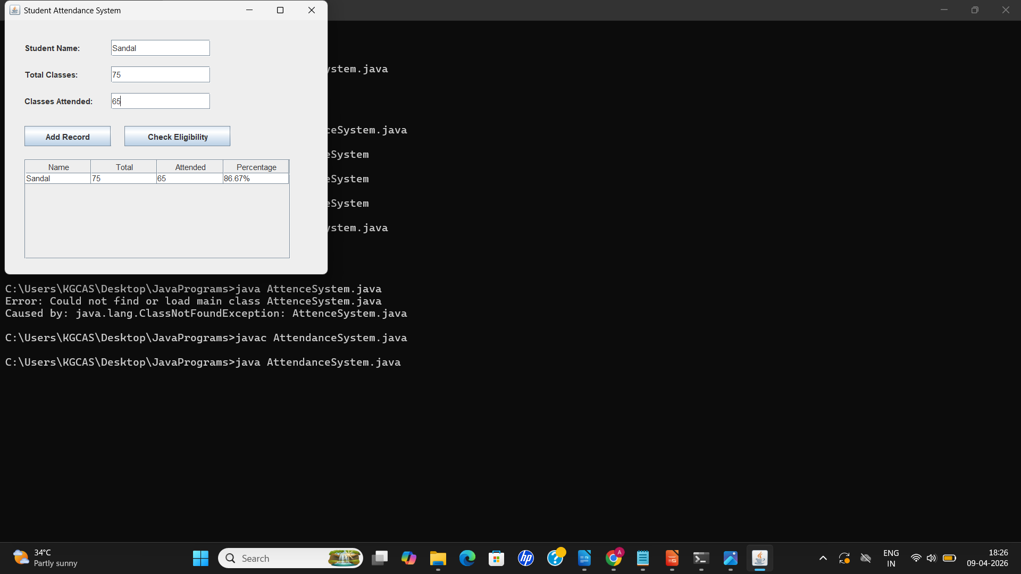

Figure 2 : Output Screen

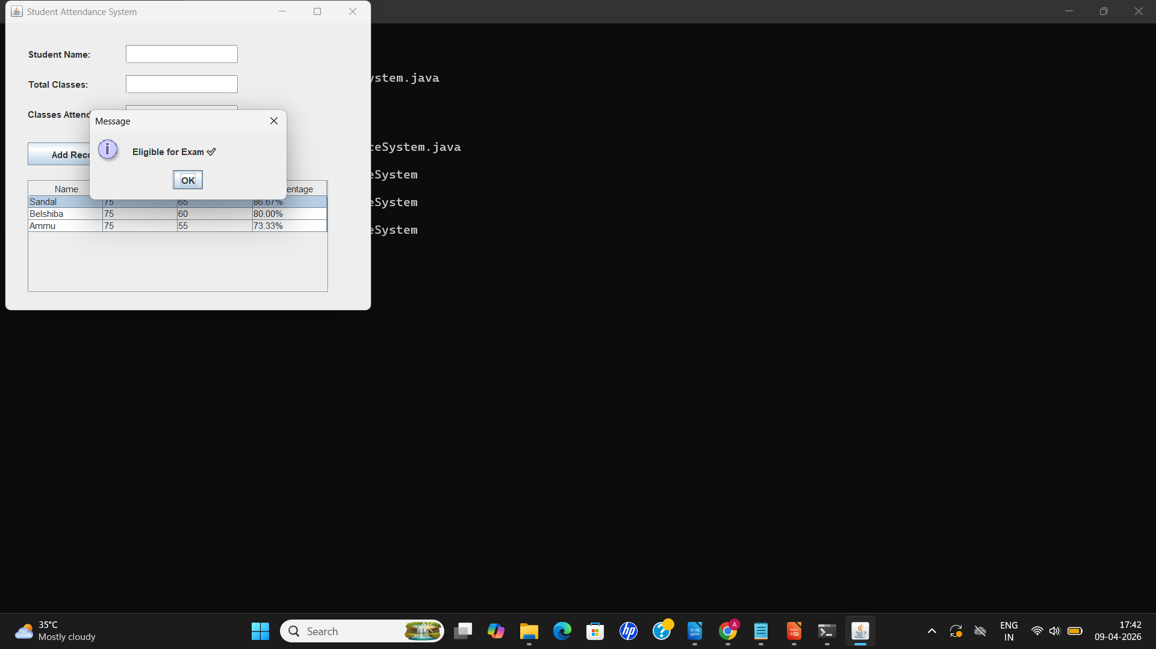

7. DISCUSSION & CONCLUSION

7.1 Discussion
The Student Attendance Monitoring and Eligibility Verification System is a simple yet effective solution for managing student attendance. By automating attendance recording and eligibility verification, the system eliminates errors associated with manual tracking and speeds up administrative tasks.
During development, Java Swing was used to create a user-friendly interface that allows easy input of student data, dynamic display in tables, and instant eligibility checking. The system demonstrates core programming concepts such as event handling, data validation, and calculation logic.
While the system works well for small-scale use, it has limitations such as the absence of a database for permanent storage and lack of multi-user support. Future enhancements could include database integration, login systems, subject-wise attendance, and report generation in Excel or PDF formats.

7.2 Conclusion
The project successfully achieves its objectives of automating attendance tracking and verifying student eligibility based on attendance percentage. It provides:
- A clear, interactive interface for data entry and display
- Accurate calculation of attendance percentages
- Instant eligibility determination based on a defined threshold (≥75%)
Overall, the system reduces administrative workload, minimizes errors, and serves as a practical tool for small-scale academic use. It also provides a foundation for more advanced attendance management systems that could include databases, web interfaces, and reporting features.

8. REFERENCES

Books
Schildt, H. Java: The Complete Reference.
GeeksforGeeks. Java JTable Example.
College lecture notes on Java Programming and GUI development (2023)
Schildt, H. Java: The Complete Reference.
McGraw-Hill Education, 2018.
TutorialsPoint. Java Swing Tutorial.

Websites
https://docs.oracle.com/javase/
https://docs.oracle.com/javase/tutorial/uiswing/
https://www.tutorialspoint.com/java/java_swing.htm/

